| Please choose a lesson, or type 0 to return to course menu.

1: Principles of Analytic Graphs 2: Exploratory Graphs 3: Graphics Devices in R

4: Plotting Systems 5: Base Plotting System 6: Lattice Plotting System

7: Working with Colors 8: GGPlot2 Part1 9: GGPlot2 Part2

10: GGPlot2 Extras 11: Hierarchical Clustering 12: K Means Clustering

13: Dimension Reduction 14: Clustering Example 15: CaseStudy

Selection: 9

| Attemping to load lesson dependencies...

| Package ‘ggplot2’ loaded correctly!

| | 0%

| GGPlot2_Part2. (Slides for this and other Data Science courses may be found at github

| https://github.com/DataScienceSpecialization/courses/. If you care to use them, they must be downloaded as a

| zip file and viewed locally. This lesson corresponds to 04_ExploratoryAnalysis/ggplot2.)

...

|== | 2%

| In a previous lesson we showed you the vast capabilities of qplot, the basic workhorse function of the

| ggplot2 package. In this lesson we'll focus on some fundamental components of the package. These underlie

| qplot which uses default values when it calls them. If you understand these building blocks, you will be

| better able to customize your plots. We'll use the second workhorse function in the package, ggplot, as well

| as other graphing functions.

...

|==== | 4%

| Do you remember what the gg of ggplot2 stands for?

1: good grief

2: grammar of graphics

3: goto graphics

4: great graphics

Selection: 2

| You are doing so well!

|====== | 6%

| A "grammar" of graphics means that ggplot2 contains building blocks with which you can create your own

| graphical objects. What are these basic components of ggplot2 plots? There are 7 of them.

...

|======== | 8%

| Obviously, there's a DATA FRAME which contains the data you're trying to plot. Then the AESTHETIC MAPPINGS

| determine how data are mapped to color, size, etc. The GEOMS (geometric objects) are what you see in the

| plot (points, lines, shapes) and FACETS are the panels used in conditional plots. You've used these or seen

| them used in the first ggplot2 (qplot) lesson.

...

|=========== | 10%

| There are 3 more. STATS are statistical transformations such as binning, quantiles, and smoothing which

| ggplot2 applies to the data. SCALES show what coding an aesthetic map uses (for example, male = red, female

| = blue). Finally, the plots are depicted on a COORDINATE SYSTEM. When you use qplot these were taken care of

| for you.

...

|============= | 12%

| Do you remember what the "artist's palette" model means in the context of plotting?

1: we draw pictures

2: things get messy

3: plots are built up in layers

4: we mix paints

Selection: 3

| You got it right!

|=============== | 15%

| As in the base plotting system (and in contrast to the lattice system), when building plots with ggplot2,

| the plots are built up in layers, maybe in several steps. You can plot the data, then overlay a summary (for

| instance, a regression line or smoother) and then add any metadata and annotations you need.

...

|================= | 17%

| We'll keep using the mpg data that comes with the ggplot2 package. Recall the versatility of qplot. Just as

| a refresher, call qplot now with 6 arguments. The first 3 deal with data - displ, hwy, and data=mpg. The

| fourth is geom set equal to the concatenation of the two strings, "point" and "smooth". The fifth is facets

| set equal to the formula .~drv, and the final argument is method set equal to the string "loess". Try this

| now.  
  
> qplot(displ, hwy, data = mpg, geom = c("point", "smooth"), facets = .~drv)

| That's a job well done!

|==================== | 19%

| We see a 3 facet plot, one for each drive type (4, f, and r). The method argument specified the smoothing function

| (loess) we wanted to use to draw trend lines through the data. (We did this to avoid getting a warning message from

| R.) Now we'll see how ggplot works. We'll build up a similar plot using the basic components of the package. We'll

| do this in a series of steps.

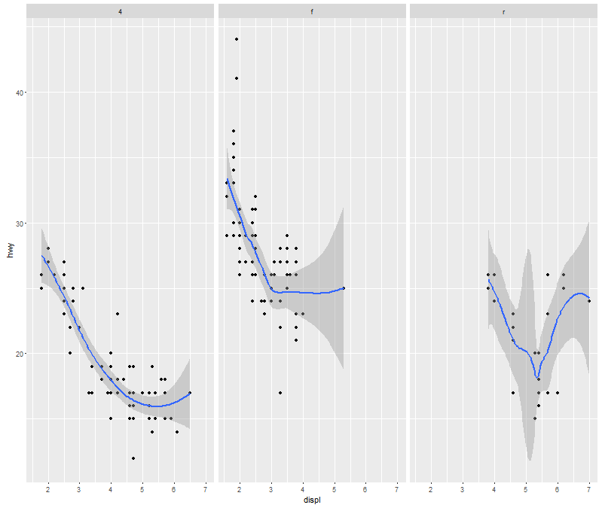

| We see a 3 facet plot, one for each drive type (4, f, and r). The method argument specified the smoothing function

| (loess) we wanted to use to draw trend lines through the data. (We did this to avoid getting a warning message from

| R.) Now we'll see how ggplot works. We'll build up a similar plot using the basic components of the package. We'll

| do this in a series of steps.

...

|====================== | 21%

| First we'll create a variable g by assigning to it the output of a call to ggplot with 2 arguments. The first is mpg

| (our dataset) and the second will tell ggplot what we want to plot, in this case, displ and hwy. These are what we

| want our aesthetics to represent so we enclose these as two arguments to the function aes. Try this now.

> g <- ggplot(mpg, aes(displ, hwy))

| Keep working like that and you'll get there!

|========================= | 23%

| Notice that nothing happened? As in the lattice system, ggplot created a graphical object which we assigned to the

| variable g.

...

|=========================== | 25%

| Run the R command summary with g as its argument to see what g contains.

> summary(g)

data: manufacturer, model, displ, year, cyl, trans, drv, cty, hwy, fl, class [234x11]

mapping: x = displ, y = hwy

faceting: facet_null()

| That's the answer I was looking for.

|============================= | 27%

| So g contains the mpg data with all its named components in a 234 by 11 matrix. It also contains a mapping, x

| (displ) and y (hwy) which you specified, and no faceting.

...

|=============================== | 29%

| Note that if you tried to print g with the expressions g or print(g) you'd get an error! Even though it's a great

| package, ggplot doesn't know how to display the data yet since you didn't specify how you wanted to see it. Now type

| g+geom_point() and see what happens.

> g + geom_point()

| That's a job well done!

|================================== | 31%

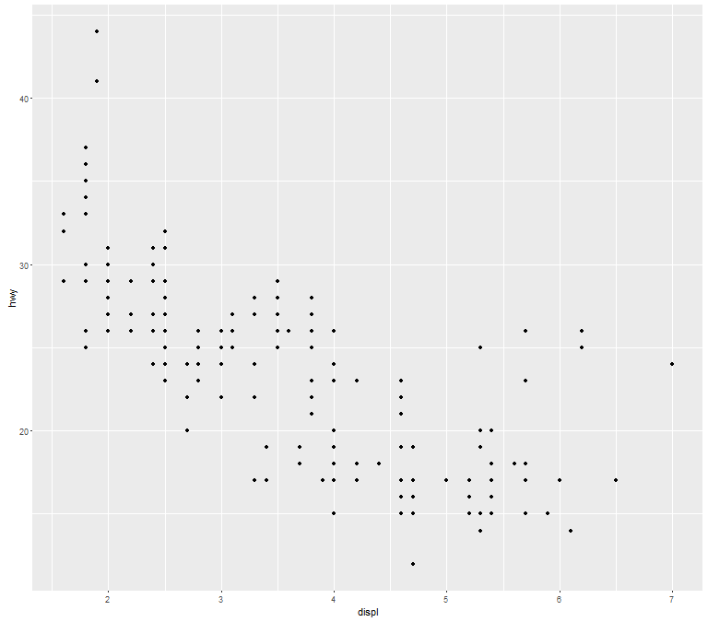

| By calling the function geom_point you added a layer. By not assigning the expression to a variable you displayed a

| plot. Notice that you didn't have to pass any arguments to the function geom_point. That's because the object g has

| all the data stored in it. (Remember you saw that when you ran summary on g before.) Now use the expression you just

| typed (g + geom_point()) and add to it another layer, a call to geom_smooth(). Notice the red message R gives you.

> g + geom_point() + geom_smooth()

| Keep working like that and you'll get there!

|==================================== | 33%

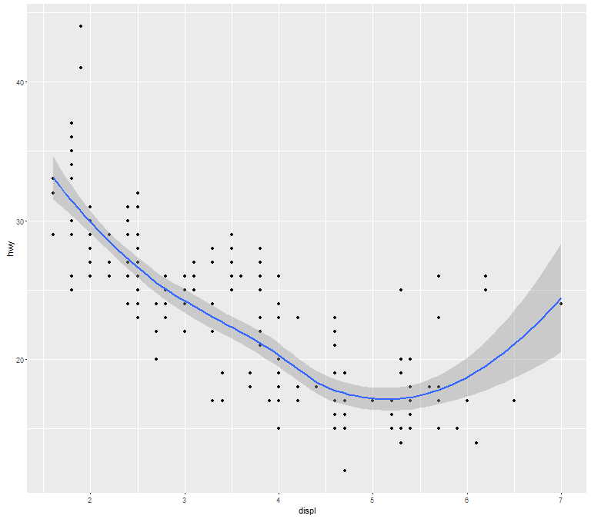

| R is telling you that it used the smoothing function loess to display the trend of the data. The gray shadow around

| the blue line is the confidence band. See how wide it is at the right? Let's try a different smoothing function. Use

| the up arrow to recover the expression you just typed, and instead of calling geom_smooth with no arguments, call it

| with the argument method set equal to the string "lm".

> g + geom_point() + geom_smooth(method = "lm")

| Your dedication is inspiring!

|====================================== | 35%

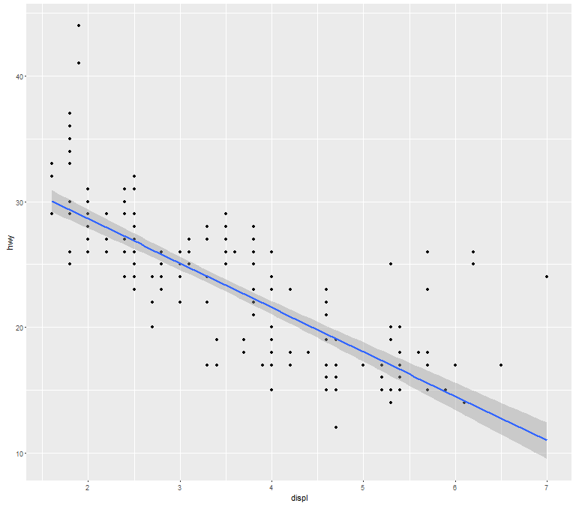

| By changing the smoothing function to "lm" (linear model) ggplot2 generated a regression line through the data. Now

| recall the expression you just used and add to it another call, this time to the function facet_grid. Use the

| formula . ~ drv as it argument. Note that this is the same type of formula used in the calls to qplot.

> g + geom_point() + geom_smooth(method = "lm") + facet_grid(.~drv)

| You are doing so well!

|======================================== | 38%

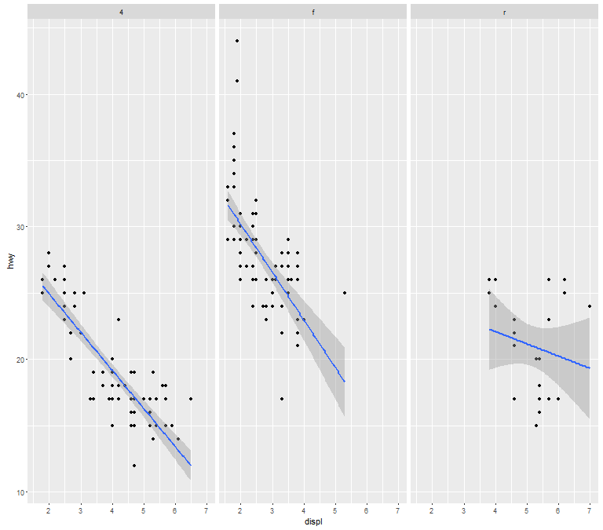

| Notice how each panel is labeled with the appropriate factor. All the data associated with 4-wheel drive cars is in

| the leftmost panel, front-wheel drive data is shown in the middle panel, and rear-wheel drive data in the rightmost.

| Notice that this is similar to the plot you created at the start of the lesson using qplot. (We used a different

| smoothing function than previously.)

...

|=========================================== | 40%

| So far you've just used the default labels that ggplot provides. You can add your own annotation using functions

| such as xlab(), ylab(), and ggtitle(). In addition, the function labs() is more general and can be used to label

| either or both axes as well as provide a title. Now recall the expression you just typed and add a call to the

| function ggtitle with the argument "Swirl Rules!".

> g + geom_point() + geom_smooth(method = "lm") + facet_grid(.~drv) + ggtitle("Swirl Rules!")

| Keep working like that and you'll get there!

|============================================= | 42%

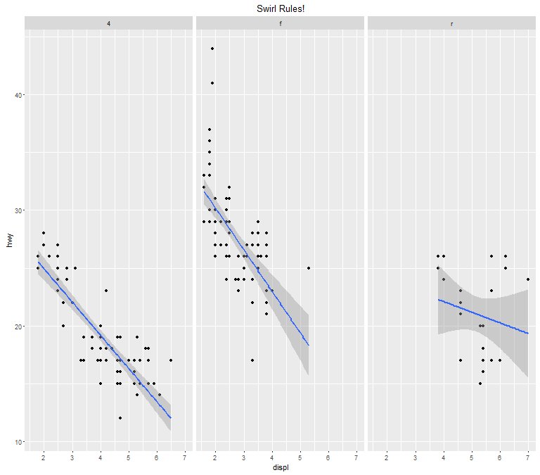

| Now that you've seen the basics we'll talk about customizing. Each of the â€œgeomâ€ functions (e.g., _point and

| _smooth) has options to modify it. Also, the function theme() can be used to modify aspects of the entire plot, e.g.

| the position of the legend. Two standard appearance themes are included in ggplot. These are theme_gray() which is

| the default theme (gray background with white grid lines) and theme_bw() which is a plainer (black and white) color

| scheme.

...

|=============================================== | 44%

| Let's practice modifying aesthetics now. We'll use the graphic object g that we already filled with mpg data and add

| a call to the function geom_point, but this time we'll give geom_point 3 arguments. Set the argument color equal to

| "pink", the argument size to 4, and the argument alpha to 1/2. Notice that all the arguments are set equal to

| constants.

> g + geom_point(color = "pink", size = 4, alpha = 1/2)

| Keep working like that and you'll get there!

|================================================== | 46%

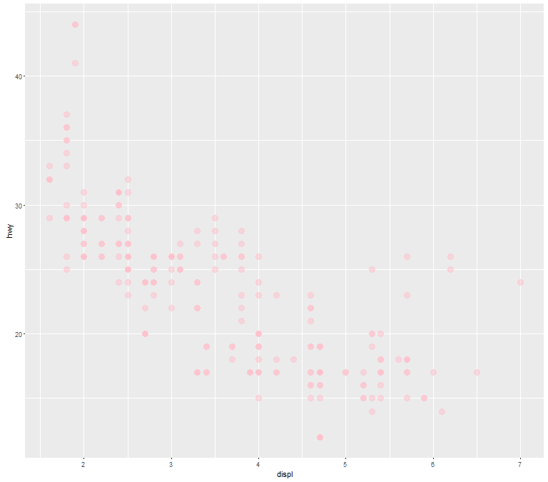

| Notice the different shades of pink? That's the result of the alpha aesthetic which you set to 1/2. This aesthetic

| tells ggplot how transparent the points should be. Darker circles indicate values hit by multiple data points.

...

|==================================================== | 48%

| Now we'll modify the aesthetics so that color indicates which drv type each point represents. Again, use g and add

| to it a call to the function geom_point with 3 arguments. The first is size set equal to 4, the second is alpha

| equal to 1/2. The third is a call to the function aes with the argument color set equal to drv. Note that you MUST

| use the function aes since the color of the points is data dependent and not a constant as it was in the previous

| example.

> g + geom_point(size = 4, alpha = 1/2, aes(color = drv))

| Excellent work!

|====================================================== | 50%

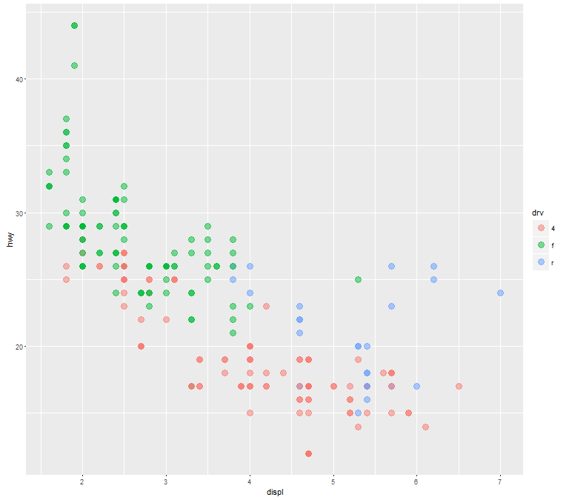

| Notice the helpful legend on the right decoding the relationship between color and drv.

...

|======================================================== | 52%

| Now we'll practice modifying labels. Again, we'll use g and add to it calls to 3 functions. First, add a call to

| geom_point with an argument making the color dependent on the drv type (as we did in the previous example). Second,

| add a call to the function labs with the argument title set equal to "Swirl Rules!". Finally, add a call to labs

| with 2 arguments, one setting x equal to "Displacement" and the other setting y equal to "Hwy Mileage".

> g + geom_point(aes(color = drv)) + labs(title = "Swirl Rules!") + labs(x = "Displacement", y = "Hwy Mileage")

| That's a job well done!

|========================================================== | 54%

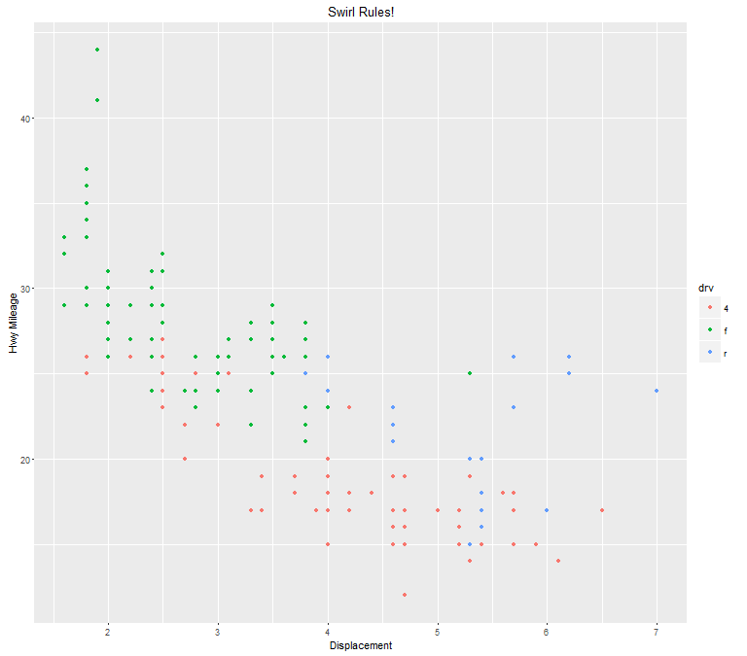

| Note that you could have combined the two calls to the function labs in the previous example. Now we'll practice

| customizing the geom_smooth calls. Use g and add to it a call to geom_point setting the color to drv type (remember

| to use the call to the aes function), size set to 2 and alpha to 1/2. Then add a call to geom_smooth with 4

| arguments. Set size equal to 4, linetype to 3, method to "lm", and se to FALSE.

> g + geom_point(aes(color = drv), size = 2, alpha = 1/2) + geom_smooth(size = 4, linetype = 3, method = "lm", se = FALSE)

| You got it!

|============================================================= | 56%

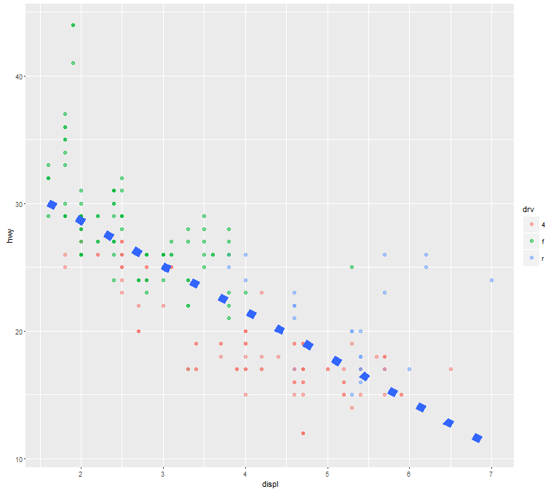

| What did these arguments do? The method specified a linear regression (note the negative slope indicating that the

| bigger the displacement the lower the gas mileage), the linetype specified that it should be dashed (not

| continuous), the size made the dashes big, and the se flag told ggplot to turn off the gray shadows indicating

| standard errors (confidence intervals).

...

|=============================================================== | 58%

| Finally, let's do a simple plot using the black and white theme, theme_bw. Specify g and add a call to the function

| geom_point with the argument setting the color to the drv type. Then add a call to the function theme_bw with the

| argument base_family set equal to "Times". See if you notice the difference.

> g + geom_point(aes(color = drv)) + theme_bw(base_family = "Times")

There were 13 warnings (use warnings() to see them)

| You got it!

|================================================================= | 60%

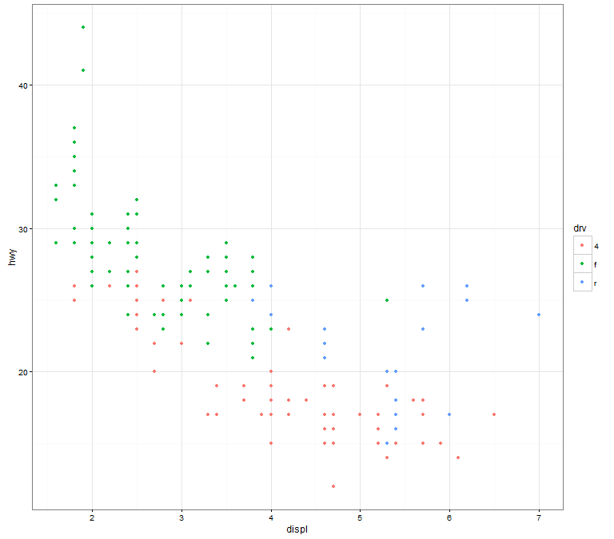

| No more gray background! Also, if you have good eyesight, you'll notice that the font in the labels changed.

...

|==================================================================== | 62%

| One final note before we go through a more complicated, layered ggplot example, and this concerns the limits of the

| axes. We're pointing this out to emphasize a subtle difference between ggplot and the base plotting function plot.

...

|====================================================================== | 65%

| We've created some random x and y data, called myx and myy, components of a dataframe called testdat. These

| represent 100 random normal points, except halfway through, we made one of the points be an outlier. That is, we set

| its y-value to be out of range of the other points. Use the base plotting function plot to create a line plot of

| this data. Call it with 4 arguments - myx, myy, type="l", and ylim=c(-3,3). The type="l" tells plot you want to

| display the data as a line instead of as a scatterplot.

warning messages from top-level task callback 'mini'

There were 40 warnings (use warnings() to see them)

> plot(myx, myy, type = "l", ylim = c(-3, 3))

| That's a job well done!

|======================================================================== | 67%

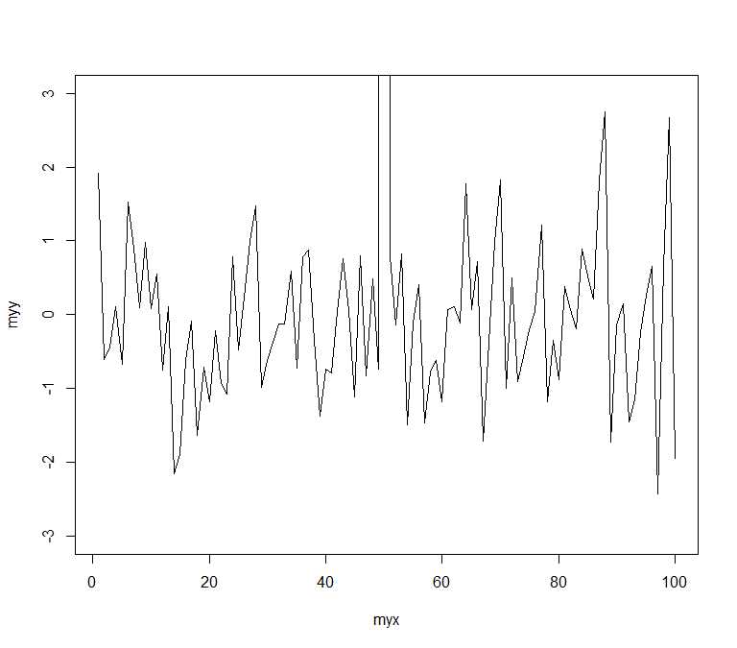

| Notice how plot plotted the points in the (-3,3) range for y-values. The outlier at (50,100) is NOT shown on the

| line plot. Now we'll plot the same data with ggplot. Recall that the name of the dataframe is testdat. Create the

| graphical object g with a call to ggplot with 2 arguments, testdat (the data) and a call to aes with 2 arguments, x

| set equal to myx, and y set equal to myy.

> g <- ggplot(testdat, aes(x = myx, y = myy))

| Nice work!

|========================================================================== | 69%

| Now add a call to geom_line with 0 arguments to g.

> g + geom_line()

| Perseverance, that's the answer.

|============================================================================ | 71%

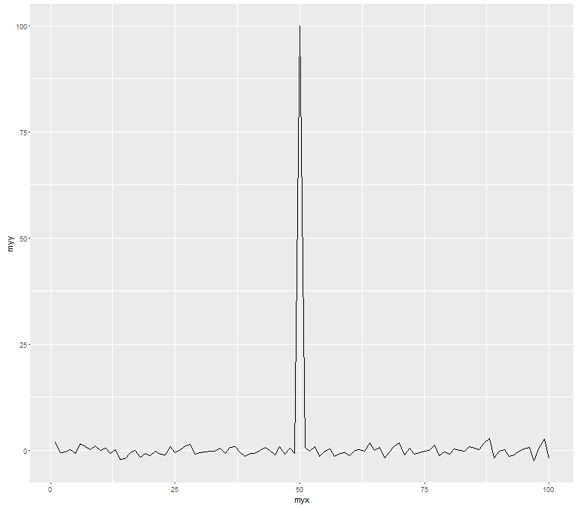

| Notice how ggplot DID display the outlier point at (50,100). As a result the rest of the data is smashed down so you

| don't get to see what the bulk of it looks like. The single outlier probably isn't important enough to dominate the

| graph. How do we get ggplot to behave more like plot in a situation like this?

...

|=============================================================================== | 73%

| Let's take a guess that in addition to adding geom_line() to g we also just have to add ylim(-3,3) to it as we did

| with the call to plot. Try this now to see what happens.

> g + geom_line() + ylim(-3, 3)

| That's the answer I was looking for.

|================================================================================= | 75%

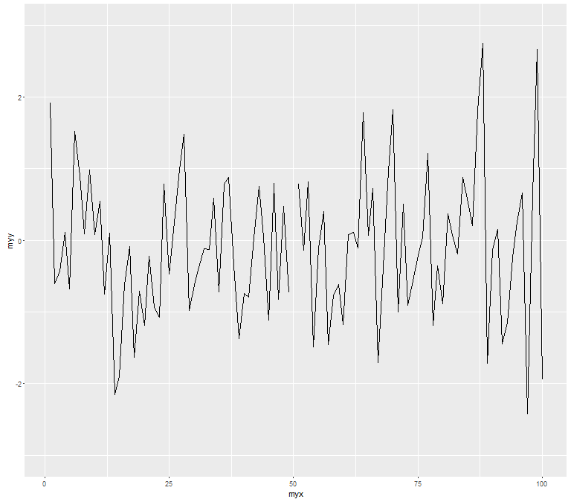

| Notice that by doing this, ggplot simply ignored the outlier point at (50,100). There's a break in the line which

| isn't very noticeable. Now recall that at the beginning of the lesson we mentioned 7 components of a ggplot plot,

| one of which was a coordinate system. This is a situation where using a coordinate system would be helpful. Instead

| of adding ylim(-3,3) to the expression g+geom_line(), add a call to the function coord_cartesian with the argument

| ylim set equal to c(-3,3).

> g + geom_line() + coord_cartesian(ylim = c(-3, 3))

| Your dedication is inspiring!

|=================================================================================== | 77%

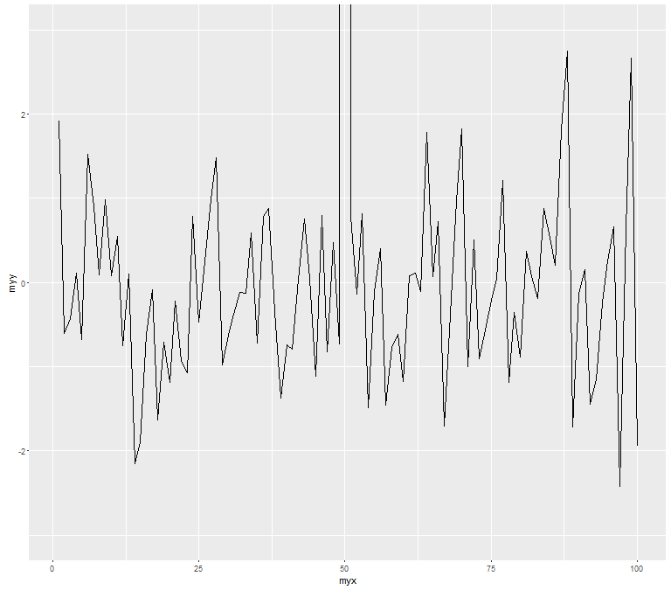

| See the difference? This looks more like the plot produced by the base plot function. The outlier y value at x=50 is

| not shown, but the plot indicates that it is larger than 3.

...

|====================================================================================== | 79%

| We'll close with a more complicated example to show you the full power of ggplot and the entire ggplot2 package.

| We'll continue to work with the mpg dataset.

...

|======================================================================================== | 81%

| Start by creating the graphical object g by assigning to it a call to ggplot with 2 arguments. The first is the

| dataset and the second is a call to the function aes. This call will have 3 arguments, x set equal to displ, y set

| equal to hwy, and color set equal to factor(year). This last will allow us to distinguish between the two

| manufacturing years (1999 and 2008) in our data.

> g <- ggplot(mpg, aes(x = displ, y = hwy, color = factor(year)))

| Nice work!

|========================================================================================== | 83%

| Uh oh! Nothing happened. Does g exist? Of course, it just isn't visible yet since you didn't add a layer.

...

|============================================================================================ | 85%

| If you typed g at the command line, what would happen?

1: I would have to try this to answer the question

2: R would return an error in red

3: a scatterplot would appear with 2 colors of points

Selection: 2

| You nailed it! Good job!

|============================================================================================== | 88%

| We'll build the plot up step by step. First add to g a call to the function geom_point with 0 arguments.

> g + geom_point()

| Excellent work!

|================================================================================================= | 90%

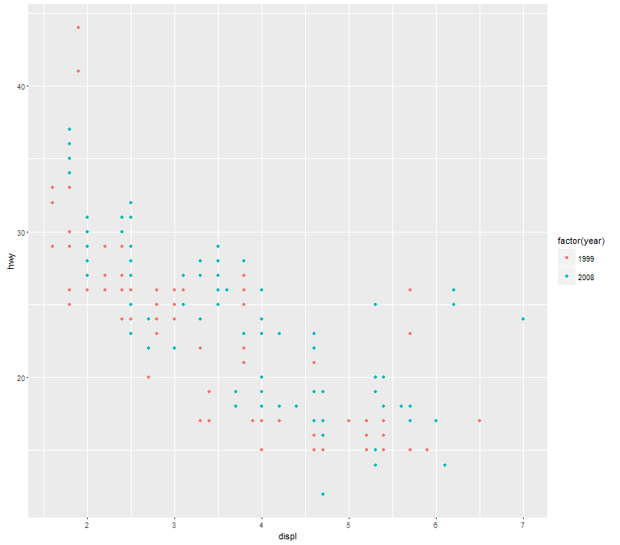

| A simple, yet comfortingly familiar scatterplot appears. Let's make our display a 2 dimensional multi-panel plot.

| Recall your last command (with the up arrow) and add to it a call the function facet_grid. Give it 2 arguments. The

| first is the formula drv~cyl, and the second is the argument margins set equal to TRUE. Try this now.

> g + geom_point() + facet_grid(drv~cyl, margins = TRUE)

| All that practice is paying off!

|=================================================================================================== | 92%

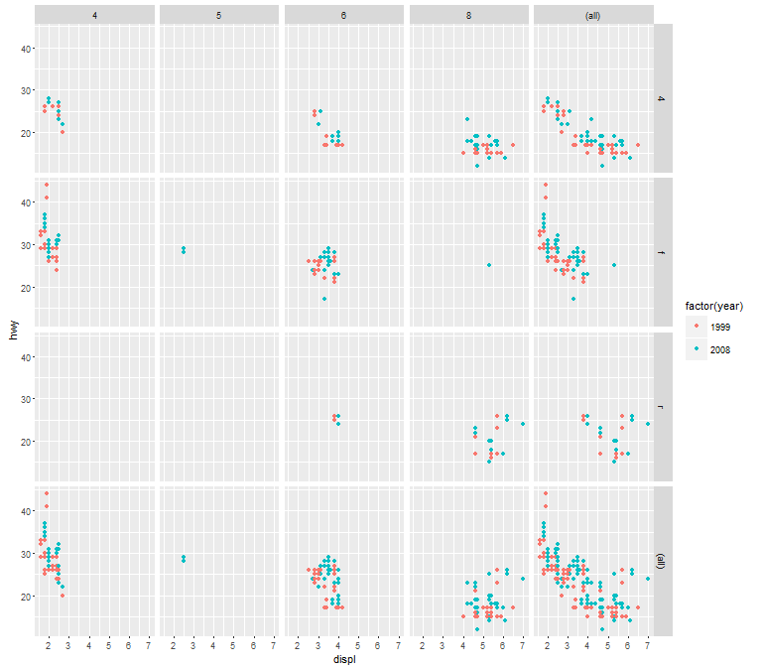

| A 4 by 5 plot, huh? The margins argument tells ggplot to display the marginal totals over each row and column, so

| instead of seeing 3 rows (the number of drv factors) and 4 columns (the number of cyl factors) we see a 4 by 5

| display. Note that the panel in position (4,5) is a tiny version of the scatterplot of the entire dataset.

...

|===================================================================================================== | 94%

| Now add to your last command (or retype it if you like to type) a call to geom_smooth with 4 arguments. These are

| method set to "lm", se set to FALSE, size set to 2, and color set to "black".

> g + geom_point() + facet_grid(drv~cyl, margins = TRUE) + geom_smooth(method = "lm", se = FALSE, size = 2, color = "black")

| Excellent work!

|======================================================================================================= | 96%

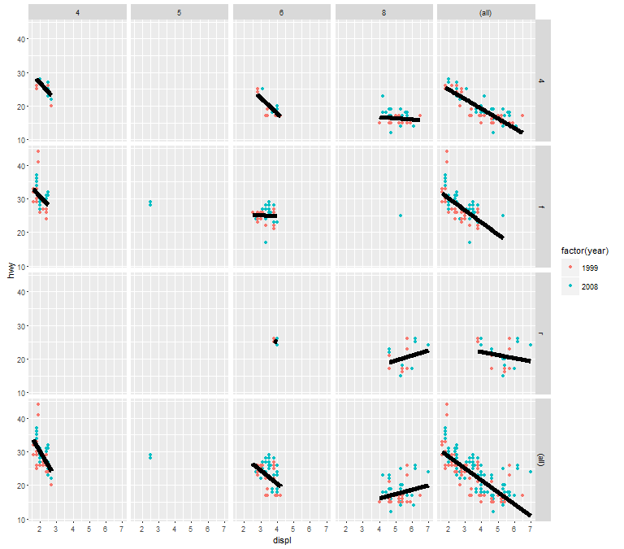

| Angry Birds? Finally, add to your last command (or retype it if you like to type) a call to the function labs with 3

| arguments. These are x set to "Displacement", y set to "Highway Mileage", and title set to "Swirl Rules!".

> g + geom_point() + facet_grid(drv~cyl, margins = TRUE) + geom_smooth(method = "lm", se = FALSE, size = 2, color = "black") + labs(x = "Displacement", y = "Highway Mileage", title = "Swirl Rules!")

| Perseverance, that's the answer.

|========================================================================================================== | 98%

| You could have done these labels with separate calls to labs but we thought you'd be sick of this by now. Anyway,

| congrats! You've concluded part 2 of ggplot2. We hope you got enough mileage out of the lesson. If you like ggplot2

| you can do some extras with the extra lesson.

...

|============================================================================================================| 100%

